Spectral coherence: GBPUSD and USDCHF
Method 21 / daily log returns / Welch magnitude-squared coherence / Alpari D1 full available history

Study setup
Logical pair: GBPUSD , USDCHF
Broker symbols: GBPUSD_i , USDCHF_i
Snapshot: 2026-11-03_majors_alpari_D1
Timeframe: D1
Matched return window: 1999-01-05 to 2026-11-02 (UTC bar dates)
Matched return count n: 7201
Dropped unfinished last bar dated 2026-11-03 UTC after a tick-volume check against the prior complete day.
Welch: fs=1.0, nperseg=256, noverlap=128, window=hann, detrend=constant
Headline: gamma^2 nearest f=1/5; also 1/21 and 1/63
Complete matched rows (Excel): GBPUSD-USDCHF_Spectral_D1.xlsx
Complete matched rows (HTML table): GBPUSD-USDCHF_Spectral_D1_data.html

Method carried forward
Magnitude-squared spectral coherence gamma^2(f) measures shared linear power between matched daily log returns of close, ln(close_t / close_t-1), at each frequency f (cycles per day). Quotes are not inverted. Welch settings are frozen: fs=1, nperseg=256, noverlap=128, window=hann, detrend=constant. Headline is gamma^2 at the frequency bin nearest f=1/5 (five-day cycle from the formula sheet). Also reported: gamma^2 nearest f=1/21 and f=1/63, mean gamma^2 over the frequency grid, and phase of the cross-spectrum at the 1/5 bin. Coherence is unsigned (0 to 1); phase carries timing. Same-sample Pearson r is a side check only. This is not causation and not a trading signal.

Results (headline)
gamma^2 near 1/5: 0.251884
bin f (1/5): 0.199219
phase at 1/5 (rad): 2.654751
gamma^2 near 1/21: 0.286589
gamma^2 near 1/63: 0.351789
mean gamma^2: 0.261682
Pearson r: -0.486083

Target-frequency summary
period | target_f | f_bin | gamma2 | phase_rad
5 | 0.2 | 0.19921875 | 0.2518841 | 2.6547509
21 | 0.04761905 | 0.046875 | 0.28658882 | -3.1383754
63 | 0.01587302 | 0.015625 | 0.35178928 | -2.7858176

Conclusion
Headline gamma^2 near f=1/5 for GBPUSD and USDCHF: 0.2519 (bin f=0.199219, phase=2.6548 rad). At ~1/21: 0.2866; at ~1/63: 0.3518. Mean gamma^2 = 0.2617. Pearson r = -0.4861. This is frequency-domain linkage, not a trading signal.

Charts
Daily closes

Daily log returns

Spectral coherence gamma^2(f)
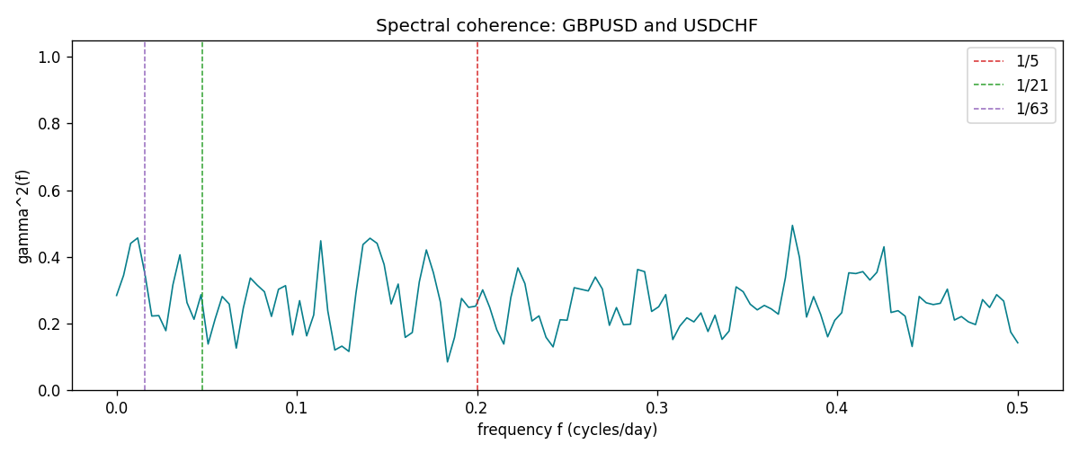

Data report
Matched rows and the coherence sheet are in the sibling Excel workbook named GBPUSD-USDCHF_Spectral_D1.xlsx. Embedding all rows as a Word table is impractical; this file holds column summaries and the first and last 15 matched rows.
Columns: time, GBPUSD_open, USDCHF_open, GBPUSD_high, USDCHF_high, GBPUSD_low, USDCHF_low, GBPUSD_close, USDCHF_close, GBPUSD_tick_volume, USDCHF_tick_volume, GBPUSD_spread, USDCHF_spread, GBPUSD_real_volume, USDCHF_real_volume, GBPUSD_log_return, USDCHF_log_return
Column summaries (matched calculation rows)
column | count | mean | std | min | 25% | 50% | 75% | max
GBPUSD_open | 7201 | 1.5160785 | 0.218271 | 1.06854 | 1.32499 | 1.51142 | 1.63167 | 2.1066
USDCHF_open | 7201 | 1.0982956 | 0.25264095 | 0.72022 | 0.92069 | 0.99019 | 1.2387 | 1.8219
GBPUSD_high | 7201 | 1.5223771 | 0.21884011 | 1.08366 | 1.32979 | 1.5182 | 1.6384 | 2.1161
USDCHF_high | 7201 | 1.1035944 | 0.25438893 | 0.73305 | 0.92495 | 0.99377 | 1.2436 | 1.8313
GBPUSD_low | 7201 | 1.5097512 | 0.21749696 | 1.03518 | 1.31949 | 1.50336 | 1.6244 | 2.0983
USDCHF_low | 7201 | 1.0931703 | 0.25105533 | 0.08565 | 0.91742 | 0.9867 | 1.2331 | 1.8121
GBPUSD_close | 7201 | 1.5161456 | 0.2182303 | 1.06879 | 1.3251 | 1.5114 | 1.63212 | 2.1065
USDCHF_close | 7201 | 1.0982864 | 0.25254184 | 0.72025 | 0.92098 | 0.9902 | 1.2387 | 1.8217
GBPUSD_tick_volume | 7201 | 94828.085 | 153546.21 | 62 | 10002 | 52900 | 91806 | 1273370
USDCHF_tick_volume | 7201 | 74189.26 | 113409.95 | 18 | 12770 | 40195 | 70240 | 858589
GBPUSD_spread | 7201 | 26.971115 | 19.193539 | 0 | 11 | 20 | 50 | 50
USDCHF_spread | 7201 | 26.114567 | 24.723753 | 0 | 5 | 16 | 50 | 100
GBPUSD_real_volume | 7201 | 3.5560898e+09 | 8.4438214e+10 | 0 | 0 | 0 | 0 | 2.4038164e+12
USDCHF_real_volume | 7201 | 2.3236557e+10 | 8.9041498e+10 | 0 | 0 | 0 | 0 | 1.9331921e+12
GBPUSD_log_return | 7201 | -2.316e-05 | 0.00564524 | -0.08388241 | -0.00312969 | 3.242e-05 | 0.00318104 | 0.03112653
USDCHF_log_return | 7201 | -7.148e-05 | 0.00659332 | -0.19545699 | -0.00335964 | 8.06e-05 | 0.00331782 | 0.09051364
First 15 matched rows (selected columns)
time | GBPUSD_log_return | USDCHF_log_return
1999-01-05 | -0.0028966287 | 0.0039424743
1999-01-06 | -0.00060452184 | 0.013605652
1999-01-07 | -0.002118709 | -0.0093883841
1999-01-08 | -0.0058954193 | 0.011040268
1999-01-11 | -0.0056851331 | 0.0052963193
1999-01-12 | 0.0022657001 | -0.0098275602
1999-01-13 | 0.0091330396 | -0.018259701
1999-01-14 | 0.0019376331 | -0.0024256692
1999-01-15 | -0.0017558204 | 0.01794228
1999-01-18 | 0.0012112405 | -0.0031856384
1999-01-19 | 0.0018745281 | -7.2518946e-05
1999-01-20 | -0.0049053846 | 0.0072259871
1999-01-21 | 0.0031518998 | -0.0038232689
1999-01-22 | 0.0024781662 | -0.0001445609
1999-01-25 | 0.0012066366 | 0.0024546976
Last 15 matched rows (selected columns)
time | GBPUSD_log_return | USDCHF_log_return
2026-10-13 | 0.0036434319 | -0.0024955621
2026-10-14 | -0.0049164679 | 0.0029388325
2026-10-15 | 0.0065976411 | -0.0097855323
2026-10-16 | 0.0037592051 | -0.0036230826
2026-10-19 | -0.0017500314 | 0.0036351779
2026-10-20 | 0.0055923442 | -0.0026281224
2026-10-21 | 0.0012476328 | -0.00040027413
2026-10-22 | 0.00022396082 | -0.0048036381
2026-10-23 | -0.0021146949 | 0.005652514
2026-10-26 | -0.0024340661 | 0.0018407959
2026-10-27 | -0.0023648393 | 0.0026100526
2026-10-28 | 0.0015771808 | -0.0010142111
2026-10-29 | 0.0035881935 | -0.0048680164
2026-10-30 | 0.0013450605 | 0.00071594559
2026-11-02 | 0.0010971256 | -0.0071459744
First 15 frequency bins
f | gamma2 | phase_rad | period_days
0 | 0.2841903 | 3.1415927 | inf
0.00390625 | 0.34474506 | -2.9542069 | 256
0.0078125 | 0.44042638 | -2.8660332 | 128
0.01171875 | 0.45674855 | -2.8395306 | 85.333333
0.015625 | 0.35178928 | -2.7858176 | 64
0.01953125 | 0.2224256 | 3.1345534 | 51.2
0.0234375 | 0.22370369 | 3.0989297 | 42.666667
0.02734375 | 0.17841454 | -3.1007138 | 36.571429
0.03125 | 0.31610207 | -3.1003671 | 32
0.03515625 | 0.40621875 | -2.9594261 | 28.444444
0.0390625 | 0.2628294 | -2.8838767 | 25.6
0.04296875 | 0.21258074 | -2.8799574 | 23.272727
0.046875 | 0.28658882 | -3.1383754 | 21.333333
0.05078125 | 0.13830256 | 2.9685376 | 19.692308
0.0546875 | 0.21367115 | 3.0588657 | 18.285714

